Parking Lot Management

BY

7-2-410-205-2020

7-2-410-2-2020

7-2-410-2-2020

7-2-410-222-2020

Prime College

A Project Submitted to

Faculty of Management, Tribhuwan University

in partial fulfillment of the requirements for the degree of

Bachelor of Information Management

Place

Month/ year

# Student’s Declaration

This is to certify that we have completed the Project entitled “Parking lot management” under the guidance of “Manoj Giri” in partial fulfillment of the requirements for the degree of Bachelor of Information Management at Faculty of Management, Tribhuwan University. This is my original work and we have not submitted it earlier elsewhere.

Date:



Signature

Name:

# Acknowledgment

Our heartfelt appreciation goes out to everyone who helped us finish our group project on parking lot management successfully. The teamwork and commitment of all members were essential to the success of this undertaking.

First and foremost, we would like to express our gratitude to Manoj Giri, our subject instructor, for his invaluable advice and assistance over the whole project. Your advice and thoughts were very helpful in determining the course of our work.

We also want to express our gratitude to our teammates for their dedication, cooperation, and pursuit of greatness. Every member was essential in researching, planning, and implementing various aspects of the parking lot management system.

We also like to thank our friends and family for their support and understanding during the challenging phases of this project.

Lastly, we would like to express our gratitude to the larger academic community as well as all the resources that have helped to shape our knowledge and skills in parking lot management.

Thank you to everyone who has been a part of this journey. Your efforts have had a long-lasting effect on our collective project's success and quality.

Sincerely,

…..

# Executive Summary

Content

Student’s Declaration 2

Acknowledgment 3

Executive Summary 4

List of Figures 7

List of Tables 8

Abbreviations 9

1 Chapter 1: Introduction 10

1.1 Introduction 10

1.2 Current situation of the organization 10

1.3 Issues/ Problems in the organization 10

1.4 Objectives of the report 10

1.5 Scope and limitation 10

1.6 Methodology of the Study 11

1.6.1 Analysis of the problem 11

1.6.2 Data Collection and Analysis 11

1.6.3 Tools used 11

2 Chapter 2: Analysis of activities done and problem solved 13

2.1 Analysis of Current System 13

2.2 Requirement Analysis 13

2.2.1 Requirement Collection Methods 13

2.2.2 Functional Requirements of the system 13

2.2.3 Non-functional requirements of the system 13

2.3 System design 13

2.3.1 System architecture 13

2.3.2 UML Class Diagram 13

2.3.3 Sequence Diagram 14

2.3.4 Activity Diagram 15

2.3.5 Database Schema 15

2.3.6 Component Diagram 15

2.3.7 Deployment Diagram 15

2.4 System Implementation 15

2.5 System Testing 17

3 Chapter 3: discussion and conclusion 17

3.1 Discussion 17

3.2 Conclusion 17

3.3 Lessons Learnt 17

3.4 Recommendations 17

Reference 17

Appendix 17

# List of Figures

Figure 1: Use-case diagram

Figure 2: Sequence diagram of log in

Figure 3: Sequence diagram of viewing,updating and deleting records

# List of Tables

# Abbreviations

Admin : Administrator

CSS : Cascading Style Sheet

HTML : HyperText Transfer Language

MySQL : My Structured Query Language

PHP : Hypertext Preprocessor

UML : Unified Modeling Language

# Chapter 1: Introduction

## Introduction

A vital component of urban infrastructure is efficient parking lot management, which addresses the issues created by the growing number of automobiles in our cities while making the most use of the limited space available. The increasing number of people living in cities and owning cars has made it more important than ever to find creative ways to improve parking operations. In addition to improving a city's general mobility, a well-managed parking lot also helps to lower traffic, improve air quality, and boost customer happiness. This introduction looks at the many aspects of parking lot management and the essential elements that are vital to making the most of this vital urban resource.

Using technology to increase convenience and efficiency is the foundation of any effective parking lot management system. Developments in technology enable more precise occupancy tracking, which improves planning and efficient use of available space. Furthermore, these advancements open the door to the application of dynamic pricing schemes, which maximize income production for cities and parking facility operators.

(WORKING OF THE SYSTEM)

## Current situation of the organization

## Issues/ Problems in the organization

## Objectives of the report

1. To minimize traffic congestion by providing accurate information about the available parking spaces and guiding vehicles to the nearest available spot.
2. To generate dynamic pricing according to the time reserved.

## Scope and limitation

**Scope**

1. Vehicle owners can see the available slots by logging in to the system.
2. Data-backup

**Limitation**

1. Vehicle owners have to depend on the admin for information about the parking space.
2. Have to be logged in to make admin.
3. (Modification to the system cannot be made by the admin)

## Methodology of the Study

### Analysis of the problem

The major issue in parking management is the use of manual registers for data recording, leading to inefficiencies, data integrity concerns, and operational limitations. This outdated method is error-prone, time-consuming, and lacks accessibility. It also poses risks of tampering and loss, hindering effective enforcement and customer satisfaction.

### Data Collection and Analysis

### Tools used

* Frontend
  + HTML
    - User Interface Design
    - Layout of pages
    - Displaying records
    - Forms and user inputs
    - Hyperlinks and navigation
  + CSS
    - Layout and Design
    - Styling elements
  + Bootstrap
    - Customized alerts and notifications
    - Pre-styled components
  + JavaScript
    - Input Validation
    - User notifications and alerts
* Backend
  + PHP
    - User Authentication and Authorization
    - Database Interaction
    - Content Delivery
  + MySQL
* Admin Data Storage
* Update Data Storage
* Vehicle Data Storage
* Session Management

# Chapter 2: Analysis of activities done and problem solved

## Analysis of Current System

## Requirement Analysis

### Requirement Collection Methods

### Functional Requirements of the system

1. Admin should be able to add, edit and delete vehicle information.
2. Search information based on vehicle owners.
3. Calculate parking fees based on duration.
4. Authentication of the admin.

### Non-functional requirements of the system

1. Provides admin login security.
2. The system should be available whenever required.

## System design

### System architecture

### UML Class Diagram

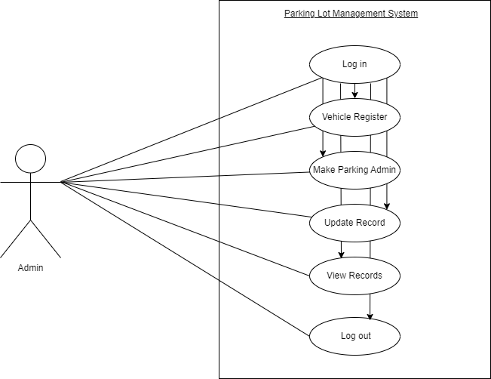

Figure no. 1

### Sequence Diagram

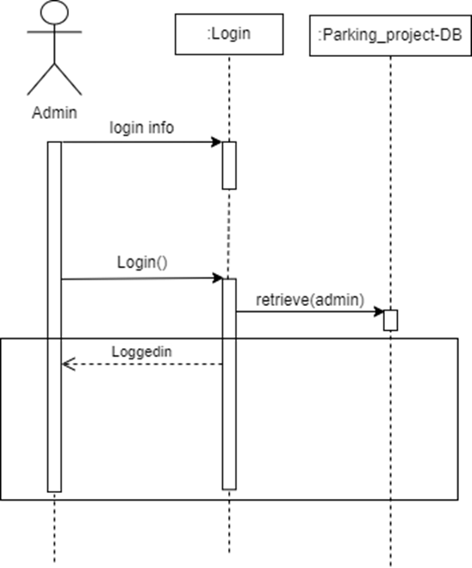

Figure no. 2

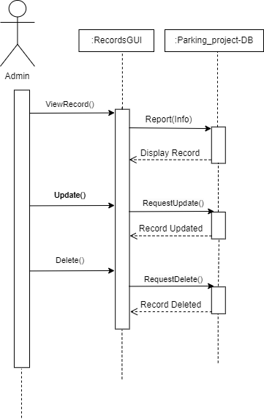

Figure no.3

### Activity Diagram

### Database Schema

### Component Diagram

### Deployment Diagram

## System Implementation

* + 1. **System Development Methodology Used**

**Iterative model**

Breaking down the project into smaller, manageable increments reduces the complexity of each task. This made it easier for us to identify and address issues as they arose. Dealing with smaller portions of the project at a time helped minimize the likelihood of encountering major issues that could disrupt the entire development process. By tackling smaller increments, the risk of major issues was minimized, and problems could be identified and addressed early on. Each iteration provided an opportunity to refine and improve the product based on opinion and testing.

**Reuse model**

Instead of building everything from scratch, we made use of pre-existing frameworks to reduce development time. By utilizing reusable components we allowed the parking management system to adapt and grow as per our project needs. This also facilitates future expansions or enhancements without requiring significant redevelopment efforts. The reuse model helped us to concentrate on the core competencies of the project rather than spending time on routine or generic tasks. In addition, reuse models often come with well-tested components which helped us to reduce the risk of errors or bugs compared to developing entirely new components. Overall, choosing a reuse model made it efficient and accelerated the development process.

* + 1. **Modules Description**

**Admin Management Module:**

The admin management module empowers administrators to oversee and administer the parking system. It includes functionalities for managing parking spaces, registering vehicles, and monitoring system activities.

Features:

Admin login and authentication.

Parking space management (addition, deletion, modification).

Vehicle registration, view records, edit, and delete.

**Vehicle Management Module:**

This module handles the registration, tracking, and management of vehicles within the parking system. It tracks vehicle entry and exit times, generates parking tickets, and calculates parking fees.

Features:

Vehicle registration and information storage.

Tracking vehicle entry and exit times.

Fee calculation based on parking duration.

## System Testing

* + 1. **Unit testing with test cases**
    2. **Integration testing with test cases**

# Chapter 3: discussion and conclusion

## Discussion

## Conclusion

## Lessons Learnt

# Reference

# Appendix

Questions:

1. figure heading
2. **class** diagram
3. recommendation ma k lekhne? pardaina
4. Test case